

**EE4620L/EE6620L/CEG4324L/CEG6324L**

**DIGITAL INTEGRATED CIRCUIT DESIGN LAB**

**Lab 2**

By

Yeoh_________ Alex________________

UID: U00931845

Email: yeoh.3@wright.edu

Submission date: 27/05/2024

“I have neither given nor received aid on this assignment, nor have I observed any violation of the Honor code”

Signature : Alex Yeoh

Date : 27/05/2024

**Table of Contents (include page #)**

I. Introduction (page 4)

II. Process (page 4)

III. Results (page 4)

IV. Conclusion (page 11)

V. Code (page 11)

**List of Figures**

Figure 1: waveform for moore 101 (page 4)

Figure 2: schematic for moore 101 (page 4)

Figure 3: hardware report for moore 101 (page 5)

Figure 4: moore 101 on Zedboard (page 5)

Figure 5: waveform for mealy 101 (page 6)

Figure 6: schematic for mealy 101 (page 6)

Figure 7: hardware report for mealy 101 (page 6)

Figure 8: mealy 101 on Zed board (page 7)

Figure 9: moore 1111 state diagram (page 7)

Figure 10: moore 1111 waveform (page 7)

Figure 11: moore 1111 schematic (page 8)

Figure 12: moore 1111 hardware report (page 8)

Figure 13: moore 1111 on Zedboard (page 9)

Figure: 14: mealy 1111 state diagram (page 9)

Figure 15: mealy 1111 waveform (page 9)

Figure 16: mealy 1111 schematic (page 10)

Figure 17: mealy 1111 hardware report (page 10)

Figure 18: mealy 1111 on Zedboard (page 11)

I. Introduction

The objective of the lab is to become more familiar with Vivado by building sequential circuits and simulating them.

II. Process

We first finished the mealy and moore vhdl files following the given state diagrams in the lab instructions. We then finish the mealy and moore testbench files by having it test the given input pattern from the lab instructions. We then simulated the mealy.vhd and moore.vhd files using their respective testbench files. We then made the state diagrams for one mealy and one moore machine for the code 1111. We then made the mealy and moore vhdl files following the state diagrams we’ve made. We then simulate the new mealy and moore vhdl files. Finally, we imported various vhdl files and constraint files to demonstrate the two mealy and two moore vhdl files working on the Zedboard.

III. Results

The following are the results for the Moore 101, Mealy 101, Moore 1111, and Mealy 1111.

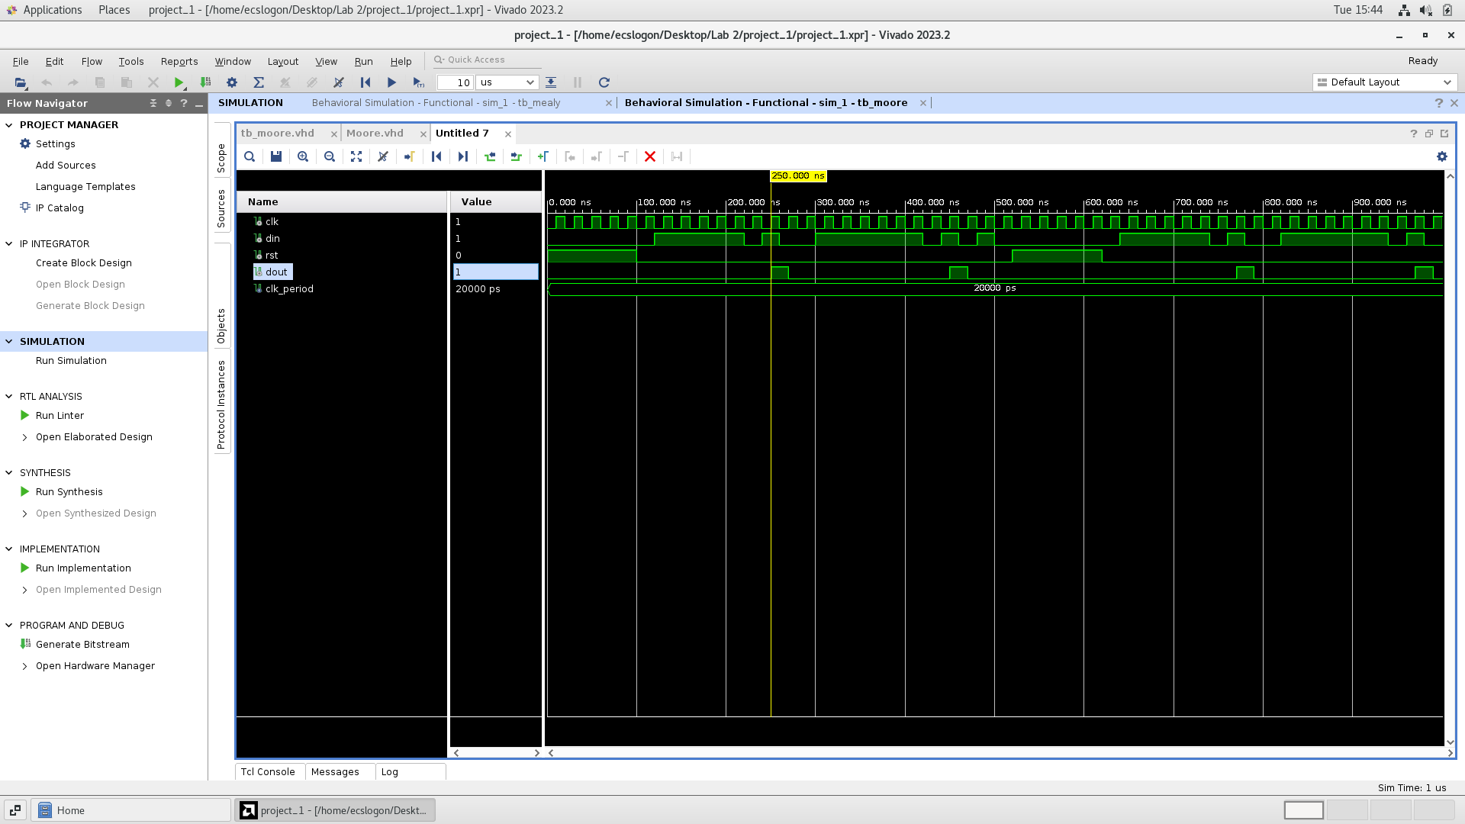

Figure 1: waveform for moore 101

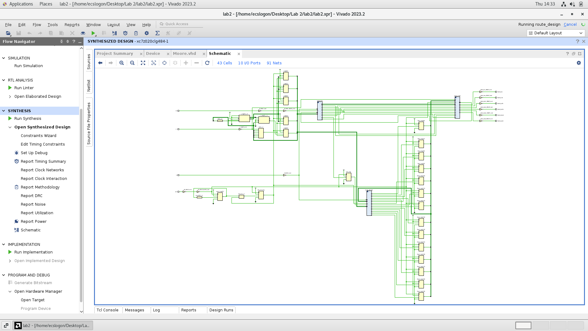

Figure 2: schematic for moore 101

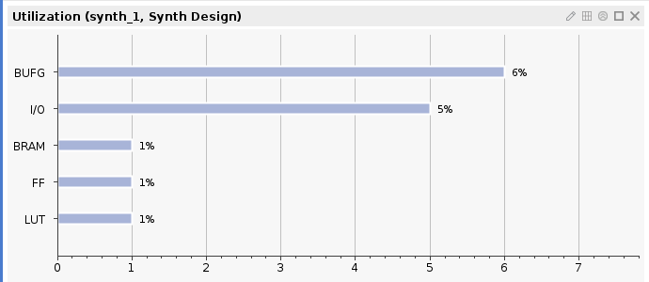

Figure 3: hardware report for moore 101

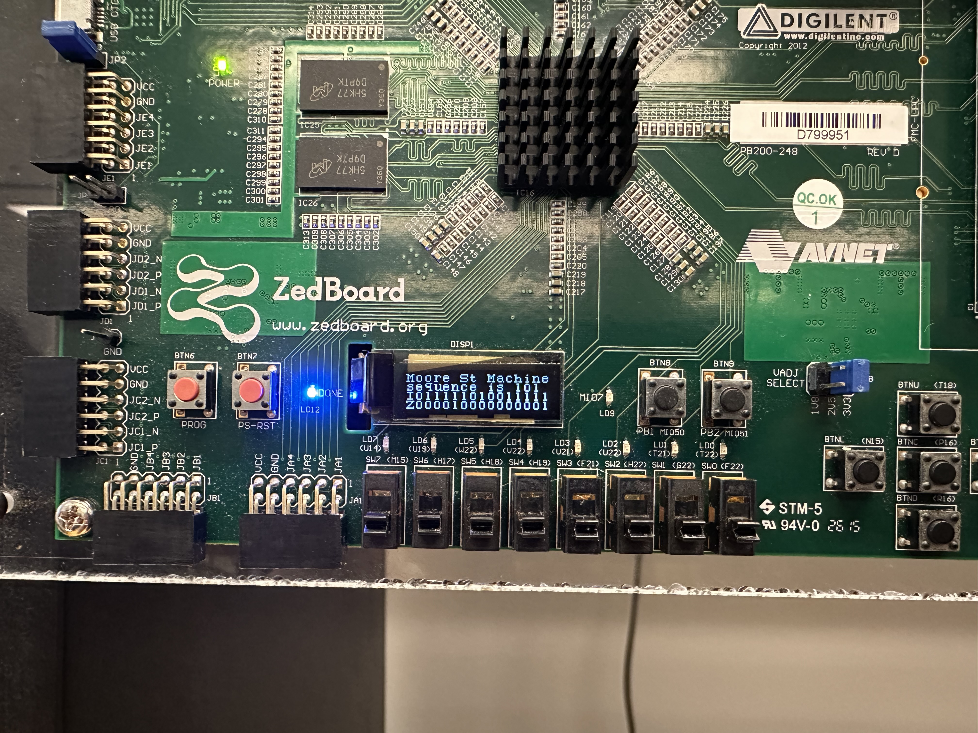

Figure 4: moore 101 on Zedboard

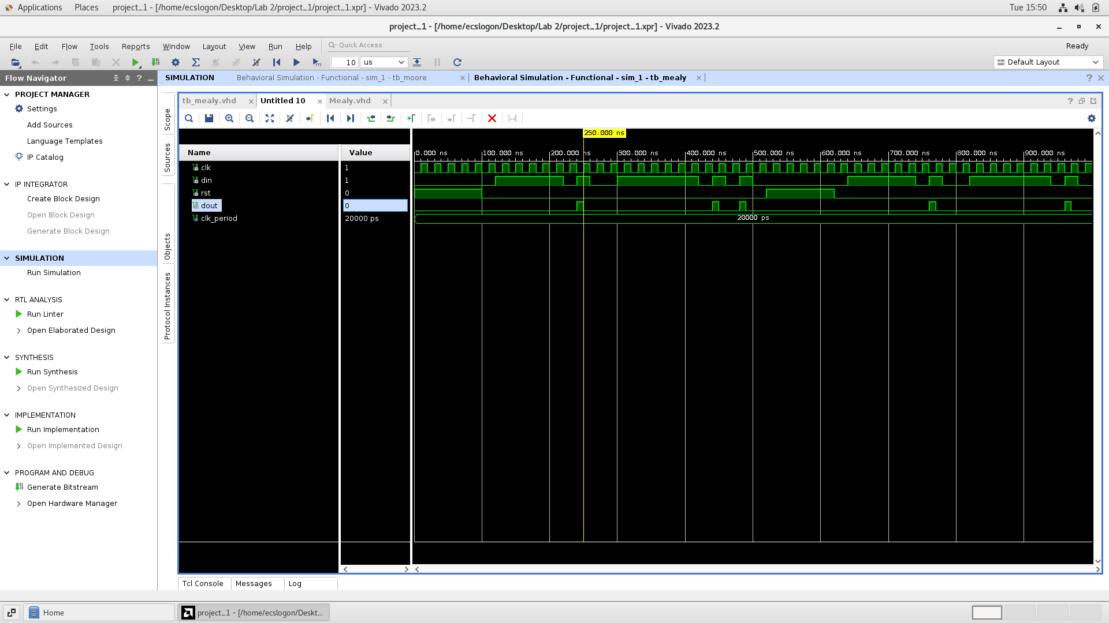

Figure 5: waveform for mealy 101

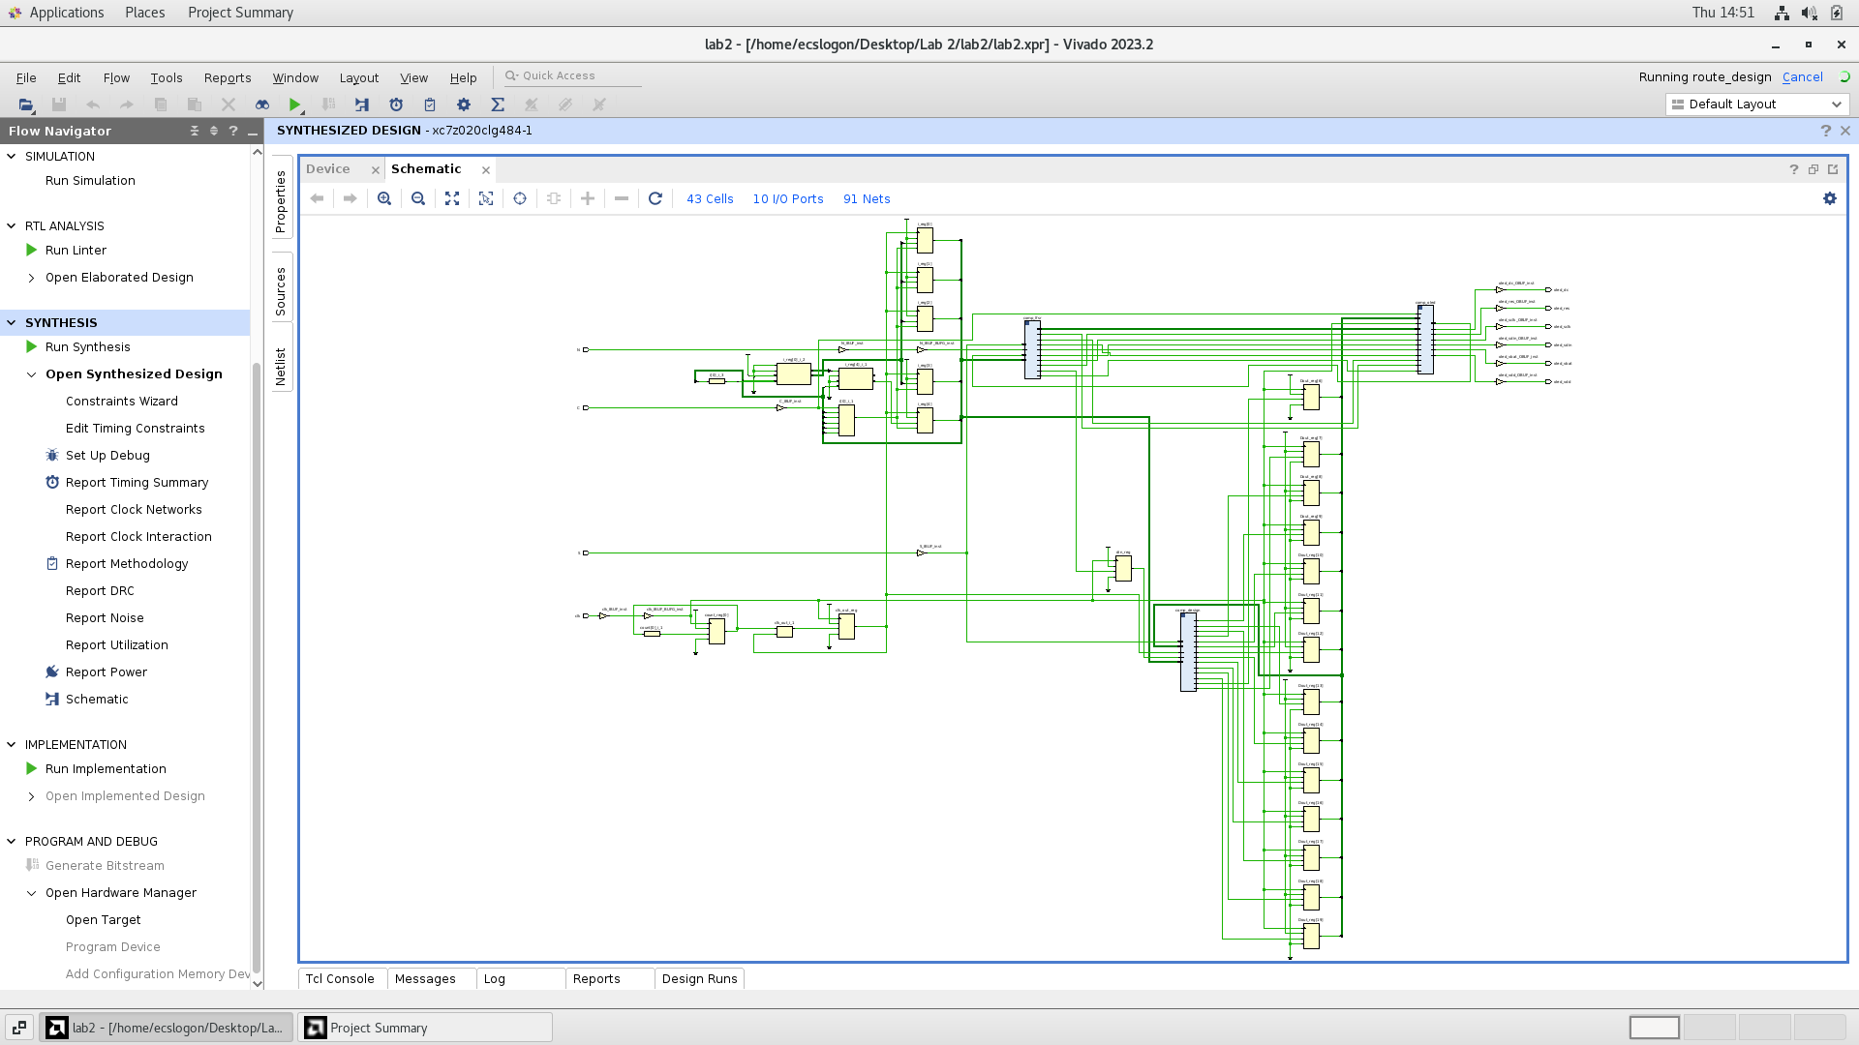

Figure 6: schematic for mealy 101

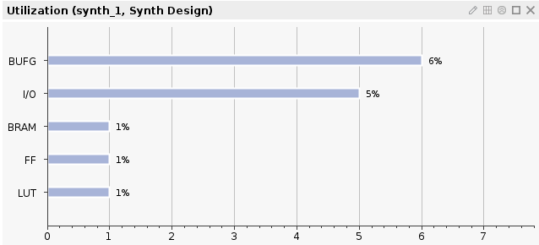

Figure 7: hardware report for mealy 101

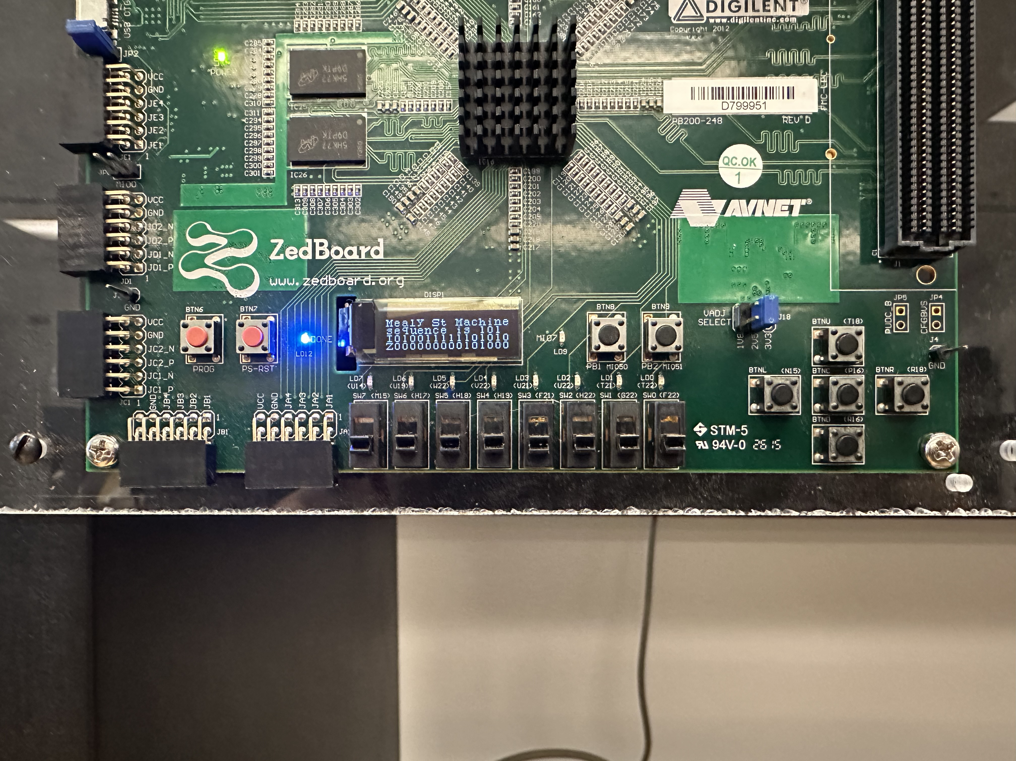

Figure 8: mealy 101 on Zed board

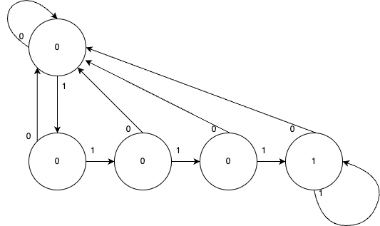

Figure 9: moore 1111 state diagram

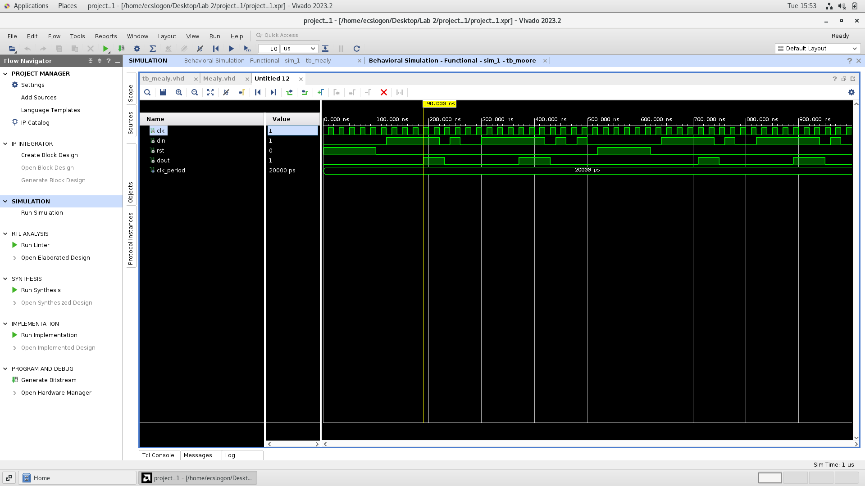

Figure 10: moore 1111 waveform

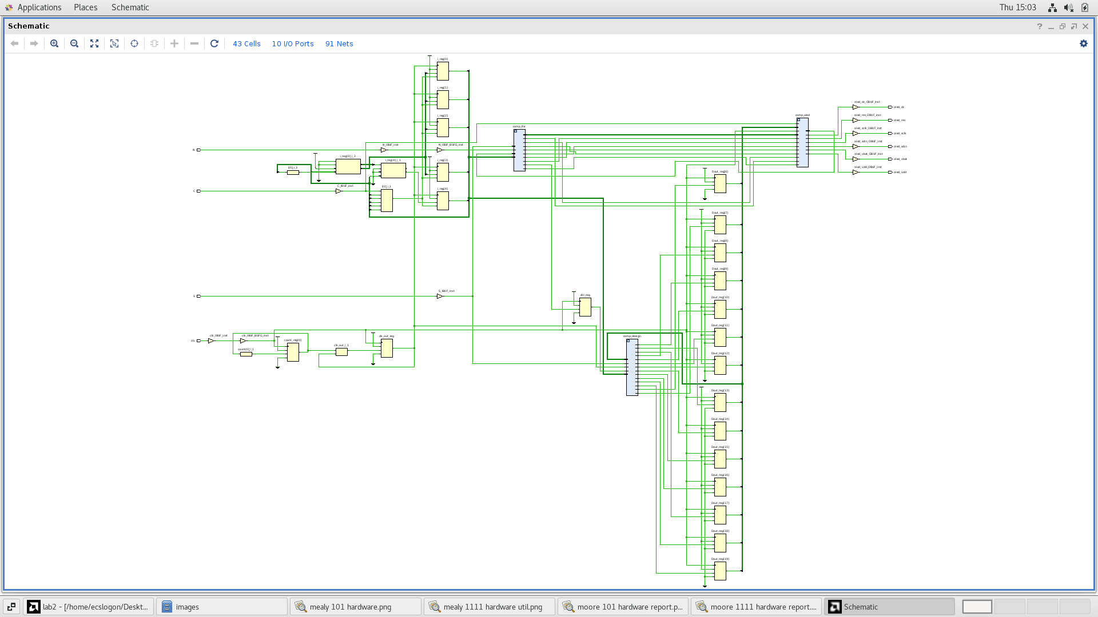

Figure 11: moore 1111 schematic

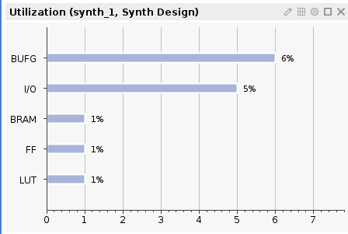

Figure 12: moore 1111 hardware report

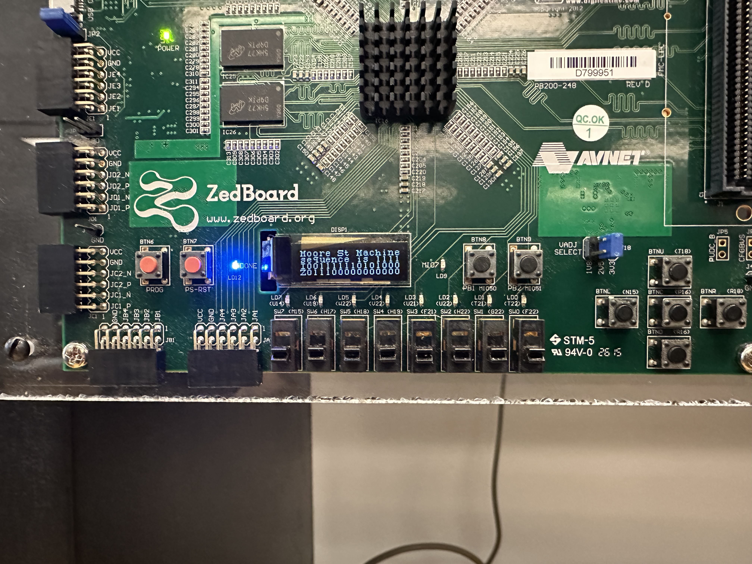

Figure 13: moore 1111 on Zedboard

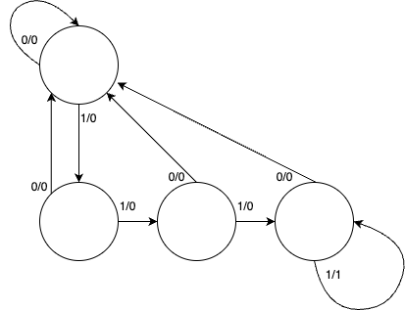

Figure: 14: mealy 1111 state diagram

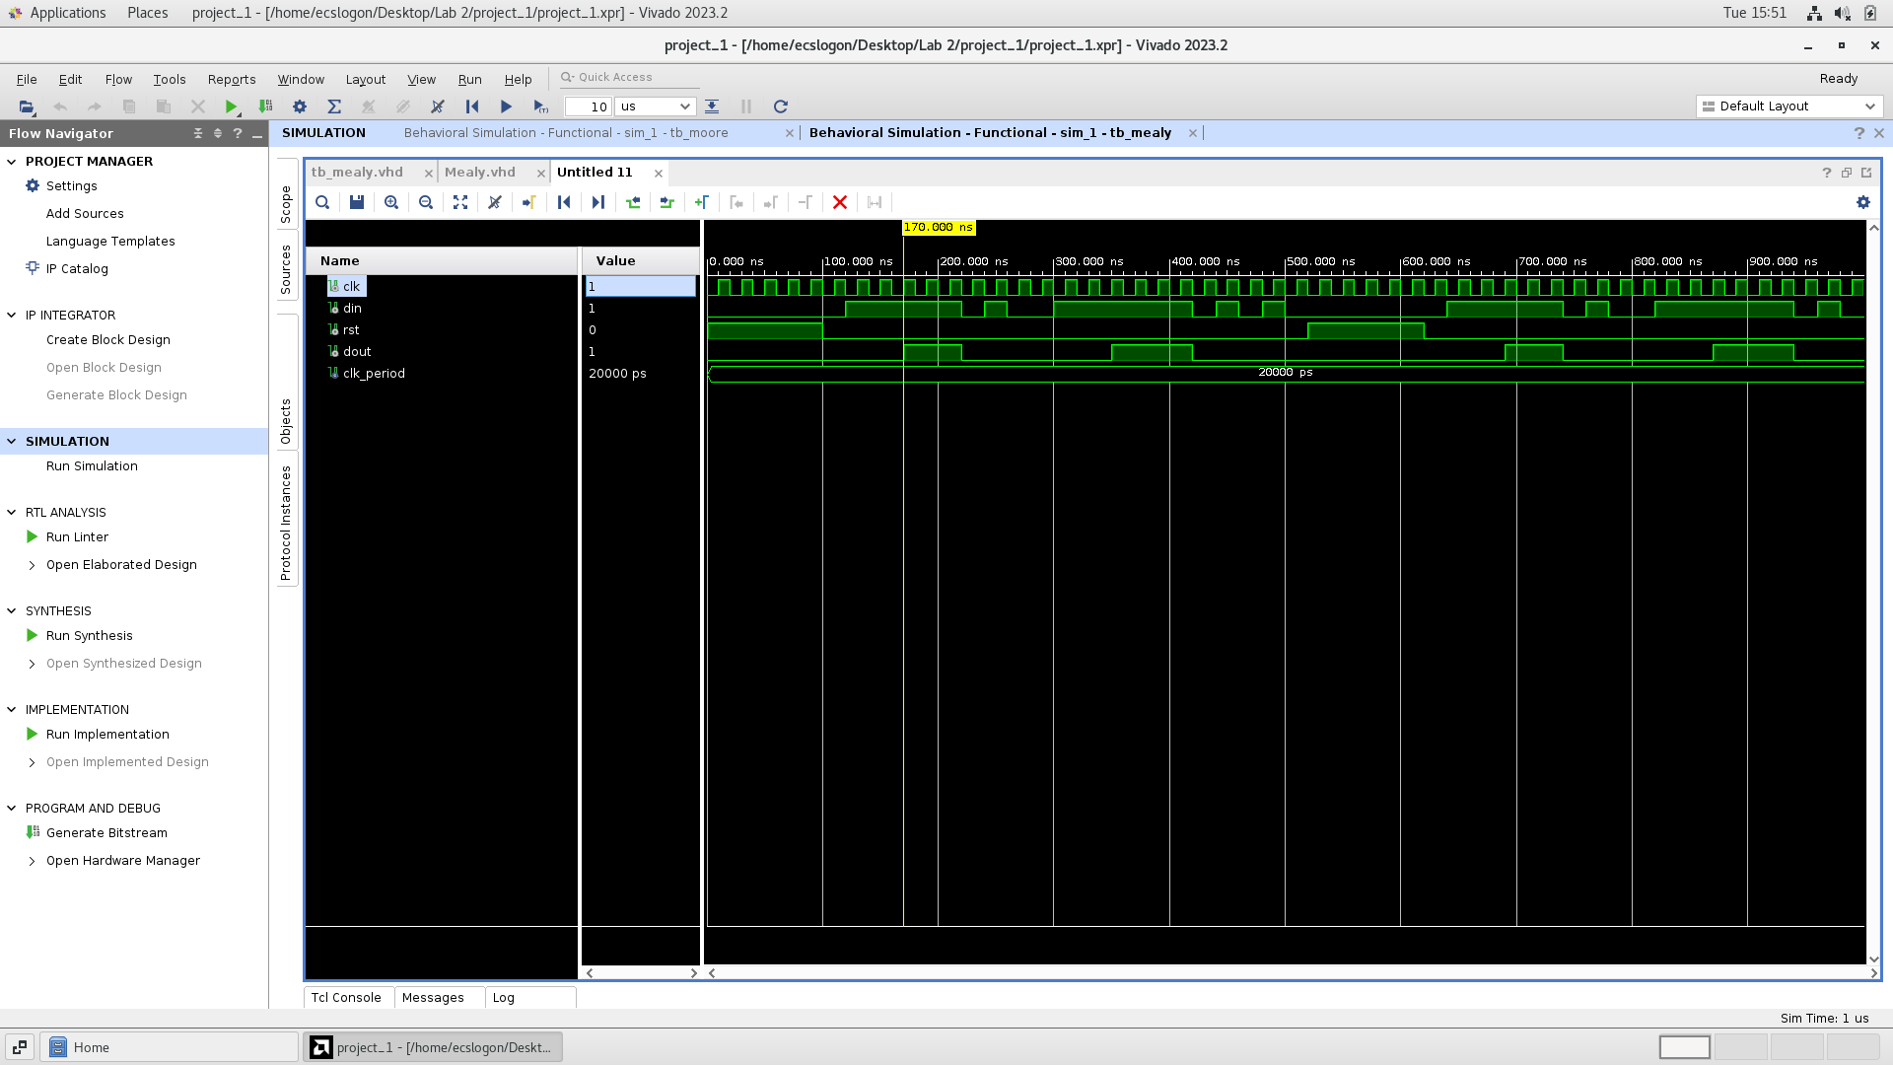

Figure 15: mealy 1111 waveform

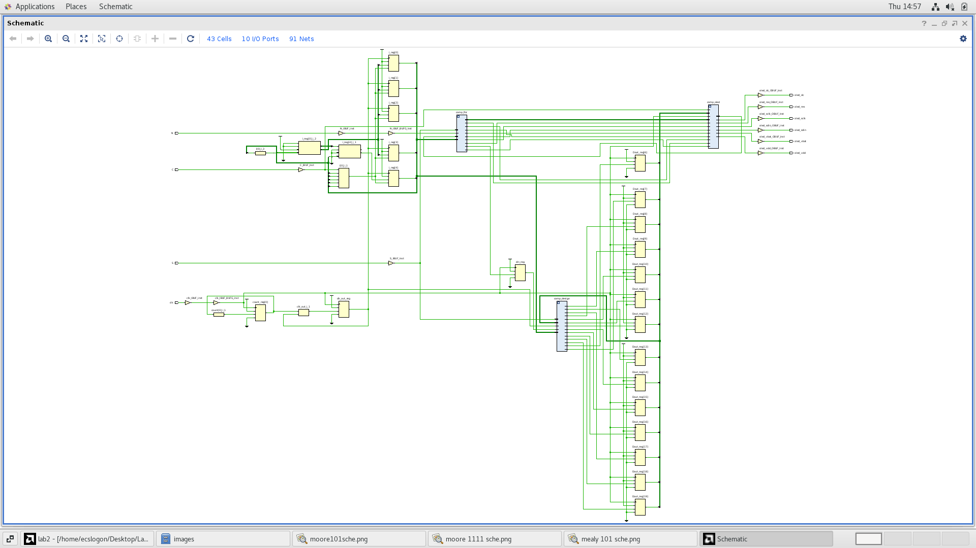

Figure 16: mealy 1111 schematic

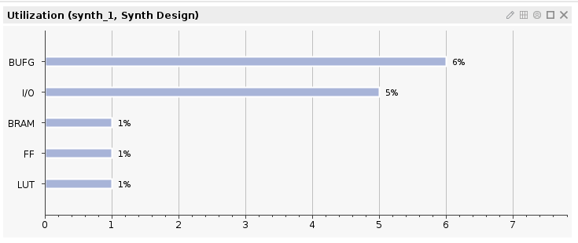

Figure 17: mealy 1111 hardware report

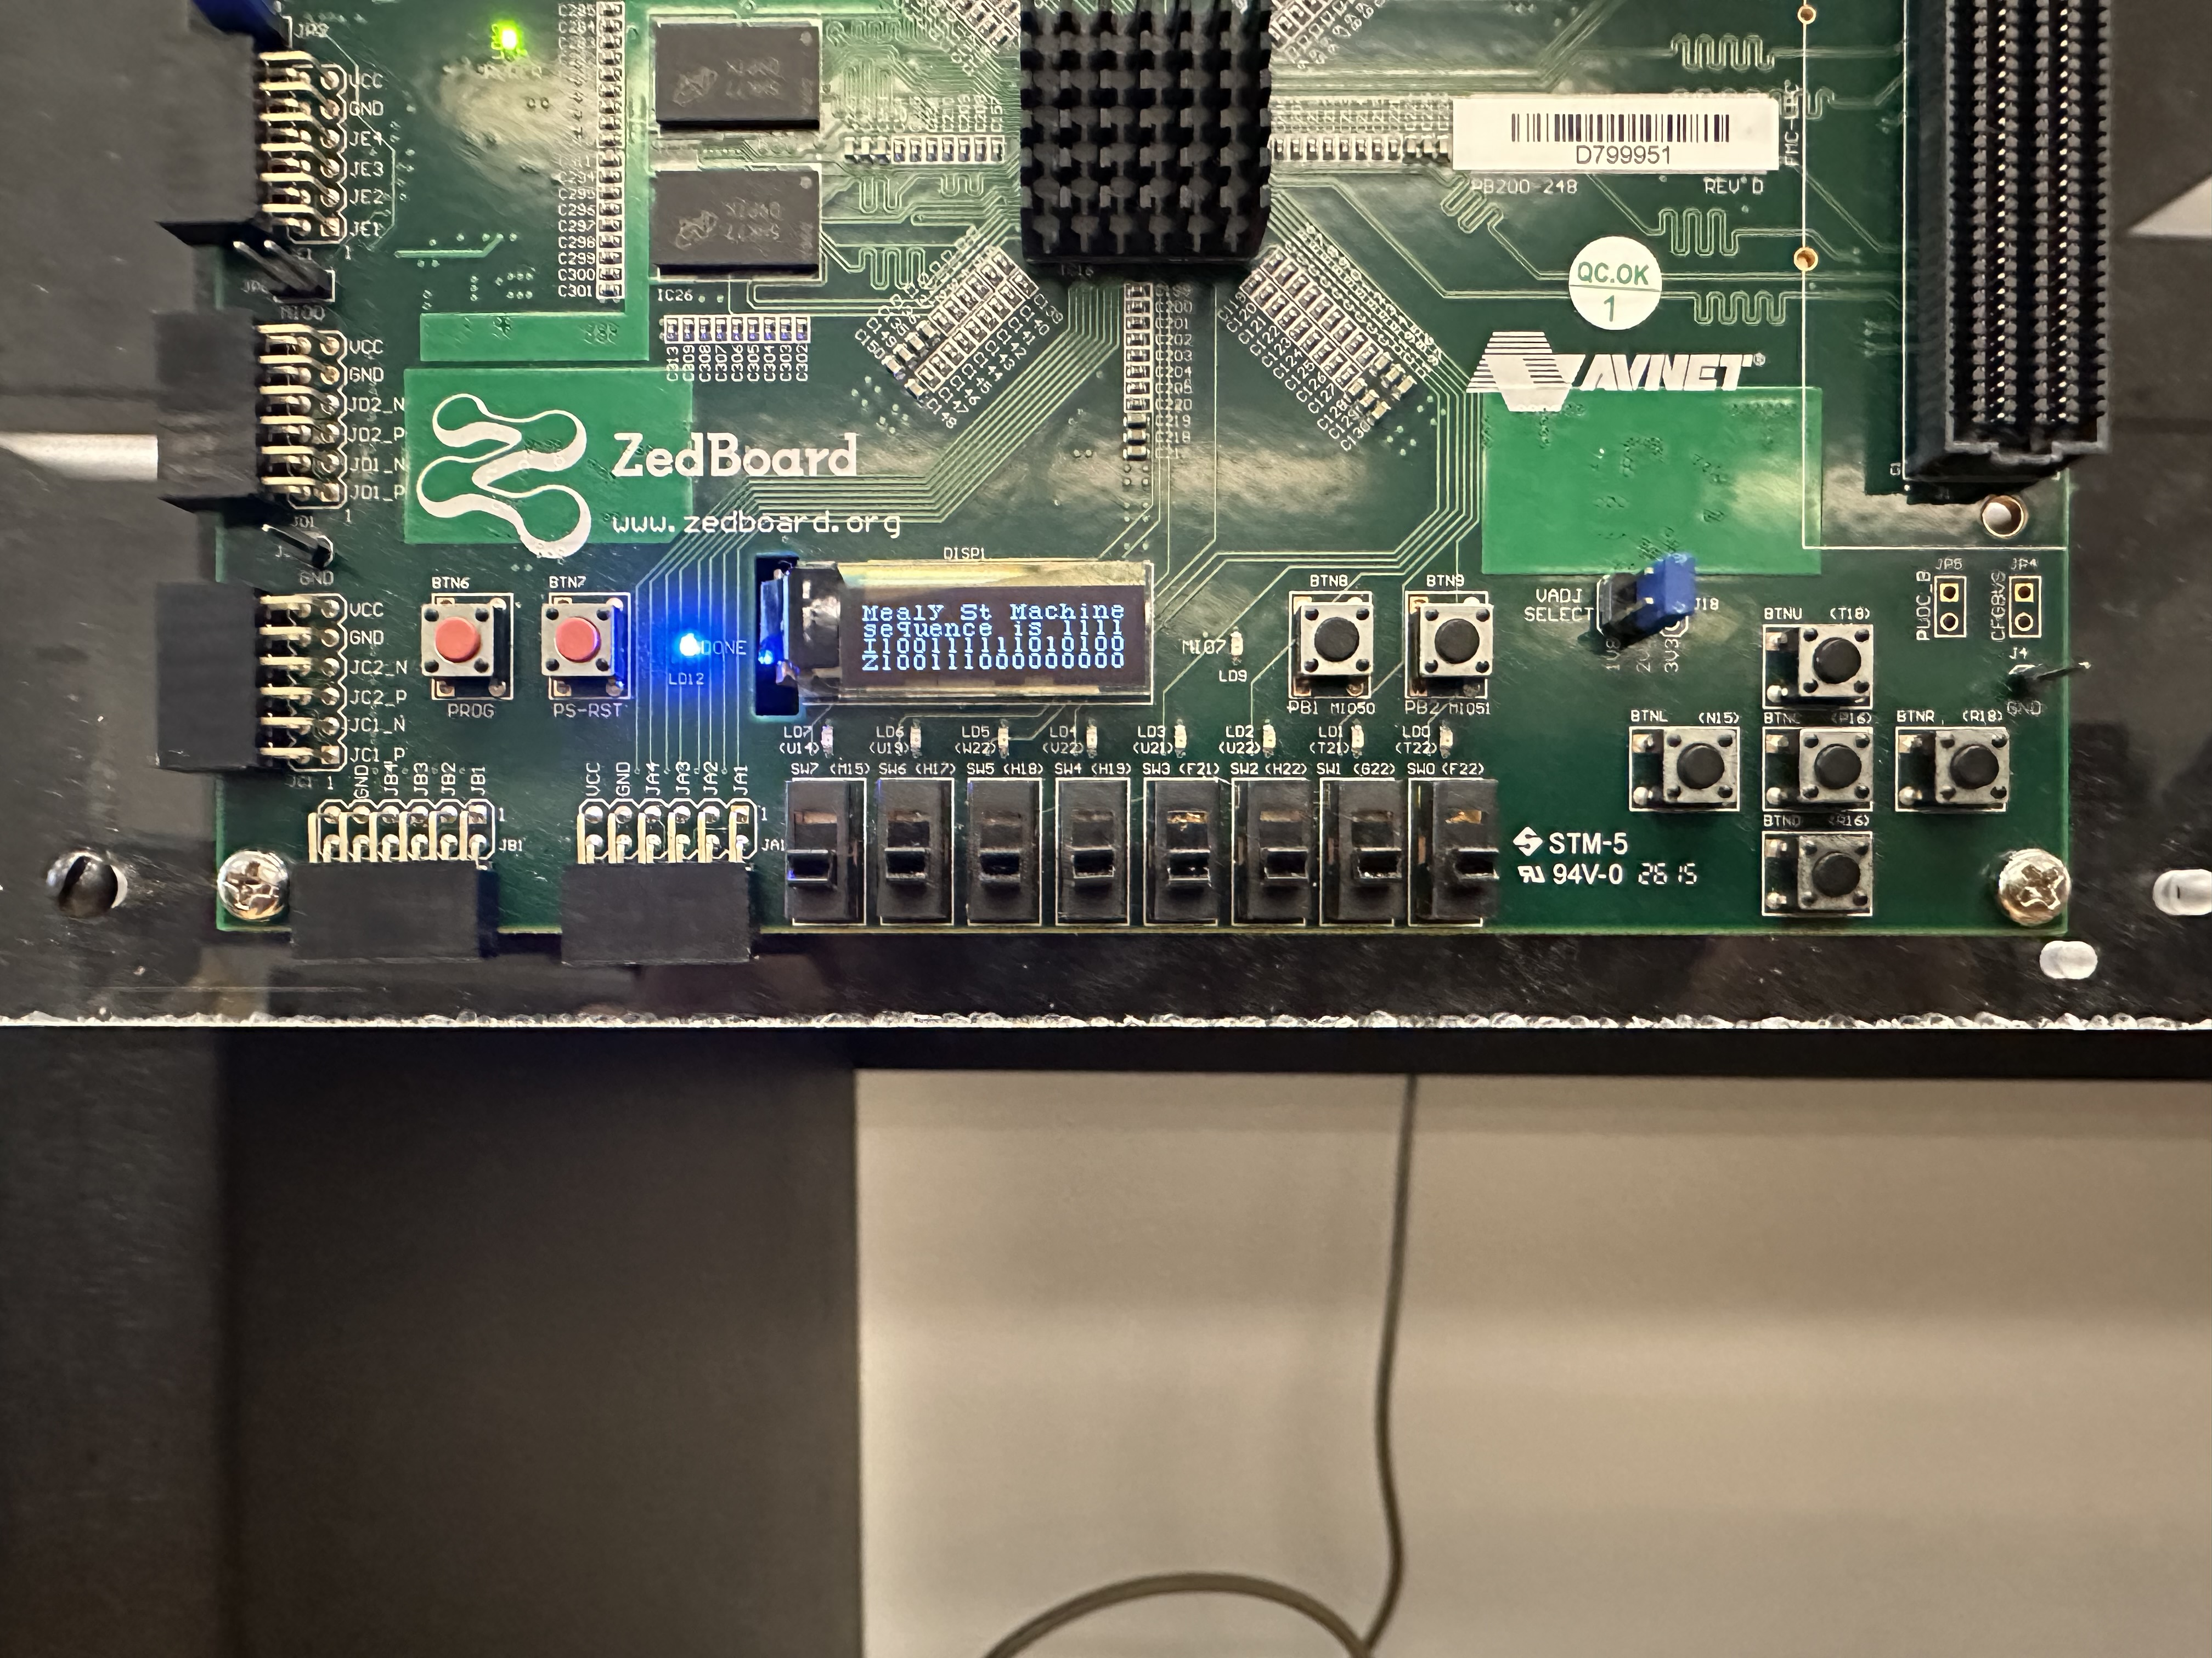

Figure 18: mealy 1111 on Zedboard

IV. Conclusion

From this lab, I have learned how to write sequential VHDL code.

V. Code

|  |
| --- |
| library IEEE;  use IEEE.STD_LOGIC_1164.ALL;    entity moore is  Port ( clk : in STD_LOGIC;  din : in STD_LOGIC;  rst : in STD_LOGIC;  dout : out STD_LOGIC);  end moore;    architecture Behavioral of moore is  type state is (st0, st1, st2 ,st3); -- declare the states  signal present_state, next_state : state;    begin    synchronous_process: process (clk)  begin  if rising_edge(clk) then  if (rst = '1') then  present_state <= st0;  else  present_state <= next_state;  end if;  end if;  end process;      output_decoder : process(present_state, din)  begin  next_state <= st0;  case (present_state) is  when st0 => if (din = '1') then  next_state <= st1 ;  else  next_state <= st0 ;  end if;  when st1 => if (din = '1') then  next_state <= st1 ;  else  next_state <= st2 ;  end if;  when st2 => if (din = '1') then  next_state <= st3 ;  else  next_state <= st0 ;  end if;  when st3 => if (din = '1') then  next_state <= st1 ;  else  next_state <= st2;  end if;  when others => next_state<=st0;  end case;  end process;    dout<='1' when present_state = st3 else '0';  end Behavioral; |

Vhdl code for moore 101

|  |
| --- |
| library IEEE;  use IEEE.STD_LOGIC_1164.ALL;    entity moore is  Port ( clk : in STD_LOGIC;  din : in STD_LOGIC;  rst : in STD_LOGIC;  dout : out STD_LOGIC);  end moore;    architecture Behavioral of moore is  type state is (st0, st1, st2 ,st3,st4); -- declare the states  signal present_state, next_state : state;    begin    synchronous_process: process (clk)  begin  if rising_edge(clk) then  if (rst = '1') then  present_state <= st0;  else  present_state <= next_state;  end if;  end if;  end process;    dout <= '1' when present_state=st4 else'0';    output_decoder : process(present_state, din)  begin  next_state <= st0;  case (present_state) is  when st0 => if (din = '1') then  next_state <= st1 ;  else  next_state <= st0 ;  end if;  when st1 => if (din = '1') then  next_state <= st2 ;  else  next_state <= st0 ;  end if;  when st2 => if (din = '1') then  next_state <= st3 ;  else  next_state <= st0 ;  end if;  when st3 => if (din = '1') then  next_state <= st4 ;  else  next_state <= st0 ;  end if;  when st4 => if (din = '1') then  next_state <= st4 ;  else  next_state <= st0 ;  end if;  when others => next_state<=st0;    end case;  end process;      end Behavioral; |

Vhdl code for moore 1111

|  |
| --- |
| LIBRARY ieee;  USE ieee.std_logic_1164.ALL;  ENTITY tb_moore IS  END tb_moore;  ARCHITECTURE behavior OF tb_moore IS  -- Component Declaration for the Unit Under Test (UUT)  COMPONENT moore  PORT(  clk : IN std_logic;  din : IN std_logic;  rst : IN std_logic;  dout : OUT std_logic  );  END COMPONENT;  --Inputs  signal clk : std_logic := '0';  signal din : std_logic := '0';  signal rst : std_logic := '0';  --Outputs  signal dout : std_logic;  -- Clock period definitions  constant clk_period : time := 20 ns;  BEGIN  -- Instantiate the Unit Under Test (UUT)  uut: moore PORT MAP (  clk => clk,  din => din,  rst => rst,  dout => dout  );  -- Clock process definitions  clk_process :process  begin  clk <= '0';  wait for clk_period/2;  clk <= '1';  wait for clk_period/2;  end process;  -- Stimulus process  stim_proc: process  begin  rst <= '1';  wait for 100 ns;  rst <= '0';    din <= '0';    wait for 20 ns;  din <= '1';    wait for 20 ns;  din <= '1';    wait for 20 ns;  din <= '1';    wait for 20 ns;  din <= '1';    wait for 20 ns;  din <= '1';    wait for 20 ns;  din <= '0';    wait for 20 ns;  din <= '1';    wait for 20 ns;  din <= '0';    wait for 20 ns;  din <= '0';    wait for 20 ns;  din <= '1';    wait for 20 ns;  din <= '1';    wait for 20 ns;  din <= '1';    wait for 20 ns;  din <= '1';    wait for 20 ns;  din <= '1';    wait for 20 ns;  din <= '1';    wait for 20 ns;  din <= '0';    wait for 20 ns;  din <= '1';    wait for 20 ns;  din <= '0';    wait for 20 ns;  din <= '1';    wait for 20 ns;  din <= '0';    wait for 20 ns;  end process;  END; |

Vhdl code for moore testbench

|  |
| --- |
| library IEEE;  use IEEE.STD_LOGIC_1164.ALL;    entity mealy is  Port ( clk : in STD_LOGIC;  din : in STD_LOGIC;  rst : in STD_LOGIC;  dout : out STD_LOGIC);  end mealy;    architecture Behavioral of mealy is  type state is (st0, st1, st2); -- declare the states  signal present_state, next_state : state;    begin    syncronous_process : process (clk)  begin  if rising_edge(clk) then  if (rst = '1') then  present_state <= st0;  else  present_state <= next_state;  end if;  end if;  end process;    next_state_and_output_decoder : process(present_state, din)  begin  dout <= '0';  case (present_state) is  when st0 => if (din = '1') then  next_state <= st1;  dout <= '0';  else  next_state <= st0;  dout <= '0';  end if;  when st1 => if (din = '1') then  next_state <= st1;  dout <= '0';  else  next_state <= st2;  dout <= '0';  end if;  when st2 => if (din = '1') then  next_state <= st1;  dout <= '1';  else  next_state <= st0;  dout <= '0';  end if;  when others => next_state <= st0;  dout <= '0';  end case;  end process;            end Behavioral; |

Vhdl code for mealy 101

|  |
| --- |
| library IEEE;  use IEEE.STD_LOGIC_1164.ALL;    entity mealy is  Port ( clk : in STD_LOGIC;  din : in STD_LOGIC;  rst : in STD_LOGIC;  dout : out STD_LOGIC);  end mealy;    architecture Behavioral of mealy is  type state is (st0, st1, st2,st3); -- declare the states  signal present_state, next_state : state;    begin    syncronous_process : process (clk)  begin  if rising_edge(clk) then  if (rst = '1') then  present_state <= st0;  else  present_state <= next_state;  end if;  end if;  end process;    next_state_and_output_decoder : process(present_state, din)  begin  dout <= '0';  case (present_state) is  when st0 => if (din = '1') then  next_state <= st1;  dout <= '0';  else  next_state <= st0;  dout <= '0';  end if;  when st1 => if (din = '1') then  next_state <= st2;  dout <= '0';  else  next_state <= st0;  dout <= '0';  end if;  when st2 => if (din = '1') then  next_state <= st3;  dout <= '0';  else  next_state <= st0;  dout <= '0';  end if;  when st3 => if (din = '1') then  next_state <= st3;  dout <= '1';  else  next_state <= st0;  dout <= '0';  end if;  when others => next_state <= st0;  dout <= '0';  end case;  end process;            end Behavioral; |

Vhdl code for mealy 1111

|  |
| --- |
| LIBRARY ieee;  USE ieee.std_logic_1164.ALL;  ENTITY tb_mealy IS  END tb_mealy;  ARCHITECTURE behavior OF tb_mealy IS  -- Component Declaration for the Unit Under Test (UUT)  COMPONENT mealy  PORT(  clk : IN std_logic;  din : IN std_logic;  rst : IN std_logic;  dout : OUT std_logic  );  END COMPONENT;  --Inputs  signal clk : std_logic := '0';  signal din : std_logic := '0';  signal rst : std_logic := '0';  --Outputs  signal dout : std_logic;  -- Clock period definitions  constant clk_period : time := 20 ns;  BEGIN  -- Instantiate the Unit Under Test (UUT)  uut: mealy PORT MAP (  clk => clk,  din => din,  rst => rst,  dout => dout  );  -- Clock process definitions  clk_process :process  begin  clk <= '0';  wait for clk_period/2;  clk <= '1';  wait for clk_period/2;  end process;  -- Stimulus process  stim_proc: process  begin  rst <= '1';  wait for 100 ns;  rst <= '0';    din <= '0';    wait for 20 ns;  din <= '1';    wait for 20 ns;  din <= '1';    wait for 20 ns;  din <= '1';    wait for 20 ns;  din <= '1';    wait for 20 ns;  din <= '1';    wait for 20 ns;  din <= '0';    wait for 20 ns;  din <= '1';    wait for 20 ns;  din <= '0';    wait for 20 ns;  din <= '0';    wait for 20 ns;  din <= '1';    wait for 20 ns;  din <= '1';    wait for 20 ns;  din <= '1';    wait for 20 ns;  din <= '1';    wait for 20 ns;  din <= '1';    wait for 20 ns;  din <= '1';    wait for 20 ns;  din <= '0';    wait for 20 ns;  din <= '1';    wait for 20 ns;  din <= '0';    wait for 20 ns;  din <= '1';    wait for 20 ns;  din <= '0';    wait for 20 ns;  end process;  END; |

Vhdl code for mealy testbench